Part 2: Miêu tả vật/ phong cảnh

1. Cảnh chụp gần

* Tập chung nghe vị trí của vật
* Loại bỏ những câu liên quan đến con người

|  |  |
| --- | --- |
| Không có người   * Being => loại * All, both, none => loại * Danh từ chỉ người, V hành động => loại | Có người khung cảnh xa   * Mô tả vật dùng being => loại * Danh từ chỉ người, V hành động => loại |

Các chủ đề hay gặp:

* Architechture: house, build, bridge,….
* Vehicles: car, bike, train, boat,…
* Travel: Scenery, beach, mountain, forest= woods= jungle= rừng
* Park: bench, post lamp, umbrellar, water, river, lake
* Household object: vật dụng trong nhà

+ TV, Sofa, arm chair, table, plant, picture, clock

+ bed, pillow, blanket, curtain,…

+carpet = rug

+ railing

|  |  |
| --- | --- |
| Địa điểm và tình huống |  |

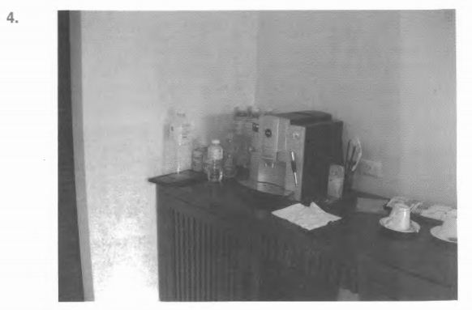

1. Coffee is being poured into cups.
2. A machine is placed on the table.
3. The table is covered with a cloth.
4. A man is drinking from a bottle

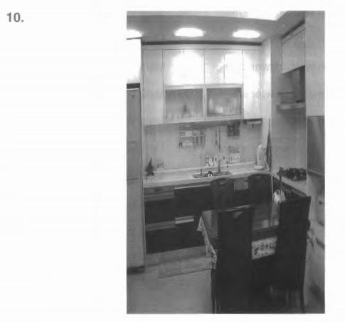

(A) Some cups are being removed from the table.

(B) There are four chairs around the round table.

(C) Some lights have been turned on.

(D) A display is being dismantled.

1. Ảnh chịp xa

|  |  |
| --- | --- |
| Lake, river, seas |  |
| Roads  Khung cảnh tổng quan |  |

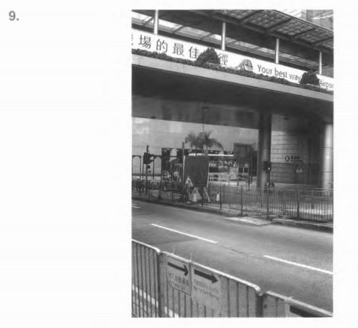

(A) There are lampposts on both sides of the road.

(B) The street is deserted.

(C) The road is being paved.

(D) Some people are going across the street.

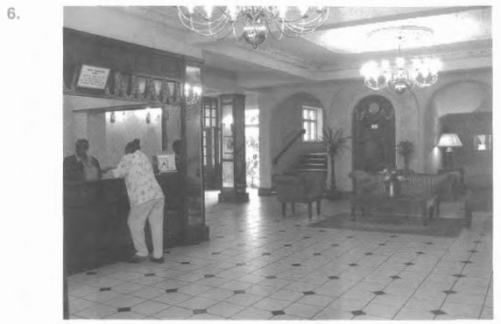

(A) The lobby is being renovated.

(B) The women are standing across from each other.

(C) They are leaving the hotel lobby.

(D) They are shaking hands.

Task 1 (File 01)

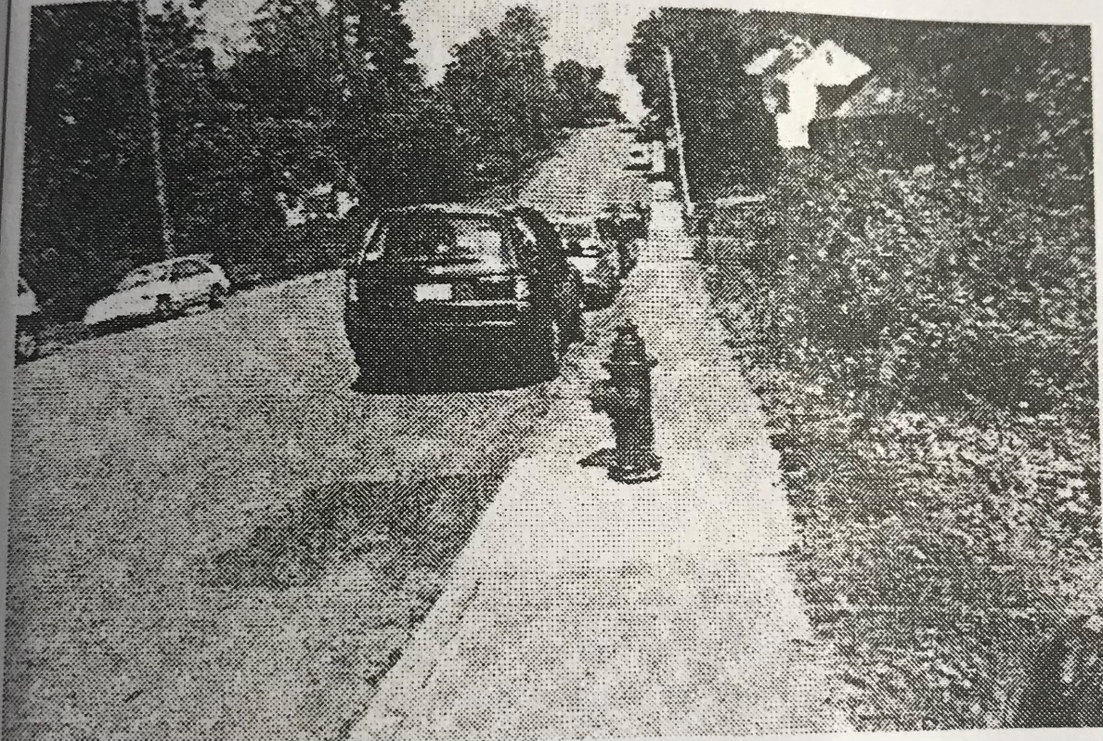

1. The cars are lined up along the street
2. There is a fire hydrant next to the curb (via he)
3. The side walk is being paved ( lat gach)
4. There are no pedestrian on sidewalk
5. The fire hydrant is being set in front of the building
6. The street is very quite

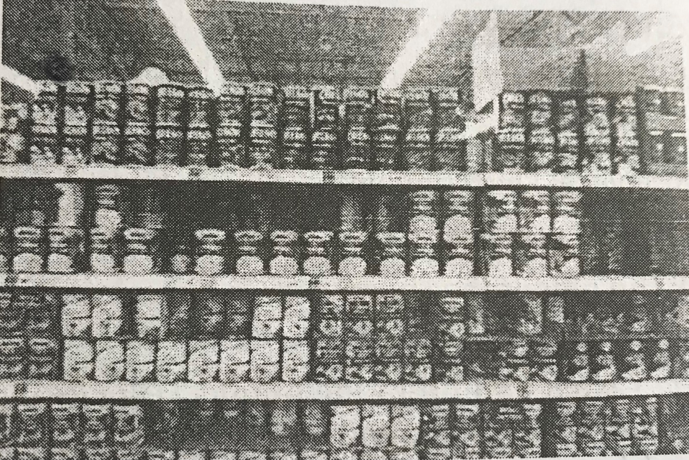

1. The shelve is filled with items
2. The shelve is being stucked with product
3. The products are in plastic bag
4. The customers purchsing a candy
5. The shelve of the bottom is empty
6. a large of plastic bag are in the upper shelve

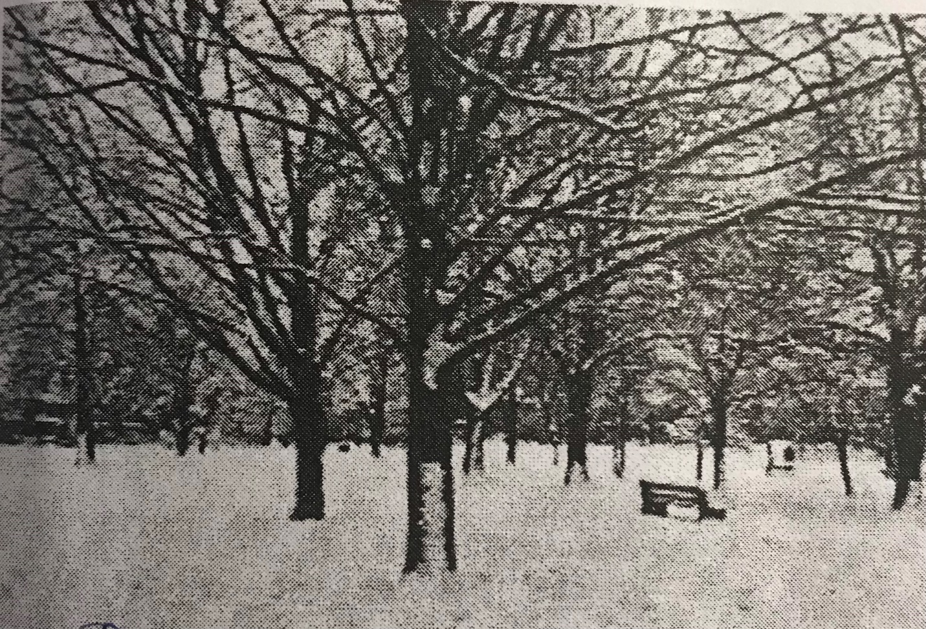

1. people are sholveing (xuc) the snow
2. there are the bench not being used
3. the ground has been coverd with snow
4. the trees are being cut down
5. there is a big part of snow in front of the building
6. the trees have lots of leaf

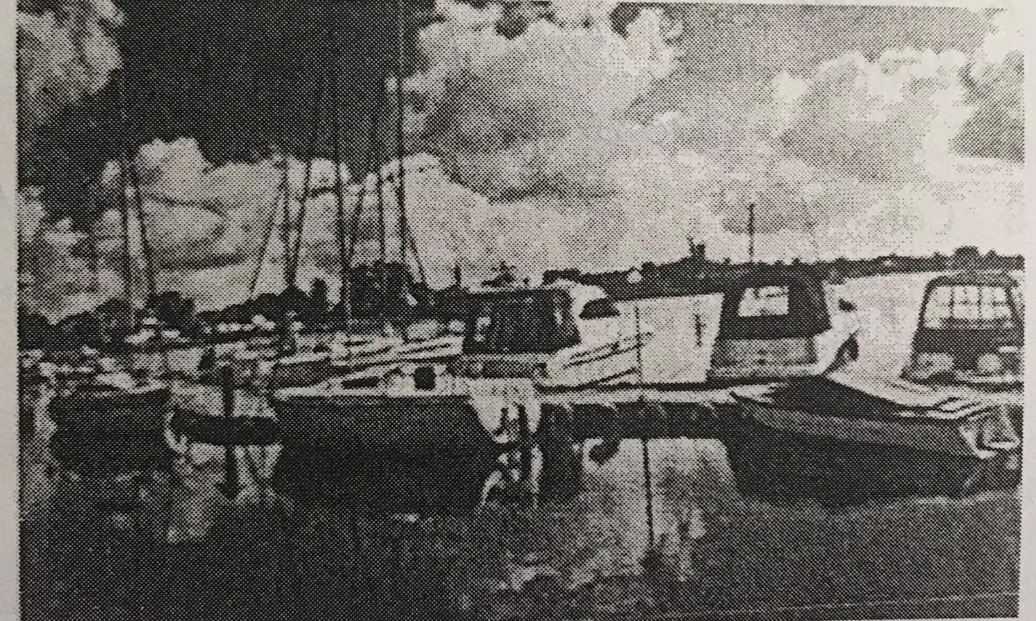

1. the ducks are swimming in lake
2. the boats are docked at the water's edge
3. people are swimming in the water
4. some objects are reflected on the water
5. people are feeding the birds
6. people are waiting on a deck of a boat

Task 2 (File 05)

1.Aisles are (lining /lined) with bookshelves.

2. Leaves are (piled/ filed) up next to the stands.

3. New inventory (is being placed/ has been place)d on the shelves.

4. The sailboat (has been towed/is being towed) through the water.

5. The boxes (are being unpacked/are unpacked) one by one.

6. Some boxes (have been loaded/have loaded) onto a moving belt.

7. There are vehicles (parking/(parked) against the curb

8. Water is (flowing/flow in) down a mountain. 9.

White smoke (is rising/ is risen) from the chimney.

10. Some type of drink (is being poured/ is poured) from the pitcher

11. Some accessories are (display/ on display) at a store.

12. Shelves (are stocking/ are stocked) with merchandise.

13. The store (is closing/ is closed) for business.

14. The horse (has tied/ is tied) up to a tree.

15. (It is/ There is) a chair on each side of the table.

16. Business cards (are being exchanged/ are exchanging) by the men.

17.Curtains are (covered/covering) the windows.

18. Several kinds of paintings (are exhibited/ are exhibiting)

19. There are trees (surrounded/surrounding) the building.

20. The dinner (has been laid/ is been laid) out on the table.

Task 2: Listen and fill in the blanks (File 06)

1. Many different items …………….the desk.

2………………. are books on top of the filing drawer.

1. There is a pile of wood ………………….on grass.
2. The orchard is full of fruit

5. The napkins ……… .. in the glasses.

6. Some fruit is ……………… weighed on the scale.

7. Cars are ………………… the train tracks.

8. Construction vehicles have been ……………... Near the trees

9. Shoes have been ……………. Into the suitcases.

10…………………..is a line of cars at the curb.

11. Plants are ………………. front of some buildings.

12. Vehicles are ………………. the crossing.

13. Vegetable sellers are . ………….... a cart.

14. Plants have been ………………... in the display case

15. Rocks are being ......in a truck,

16. The cable has been completely ……………….. into a coil.

17.The ground…..............with snow

18. some pie is being…………………..into slices

19. wheelbarrow is being………………….with stones

20. cloth has been ……………..over the glass cases

Task4: File 07

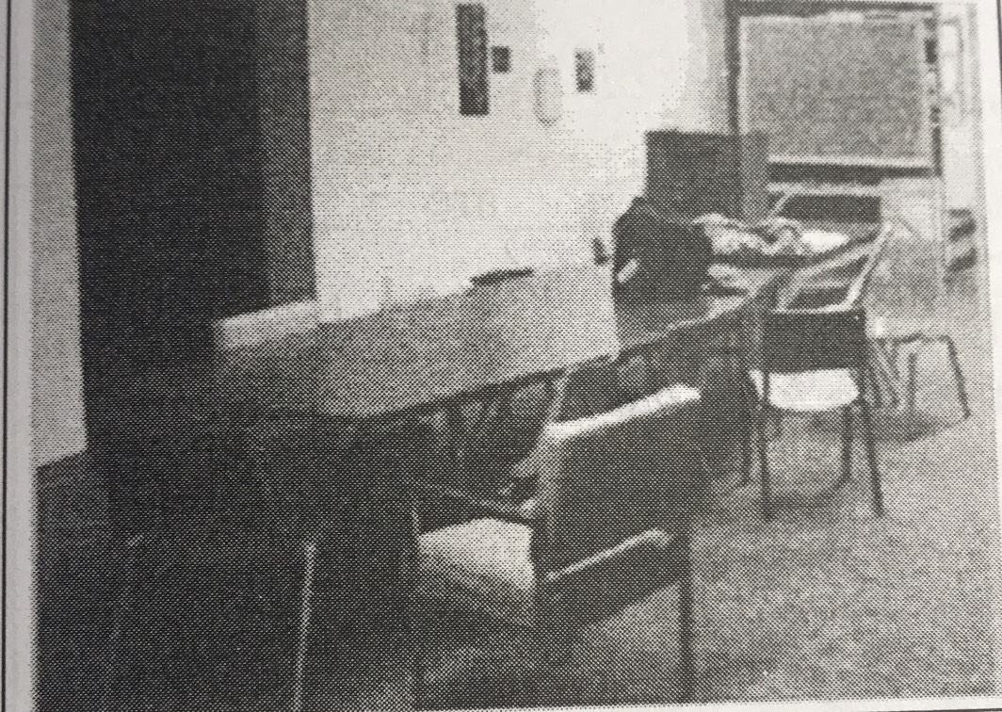

1. The room has bot been occupied
2. All of the chairs are under the table
3. The chairs are being scatter
4. The borad is upside down

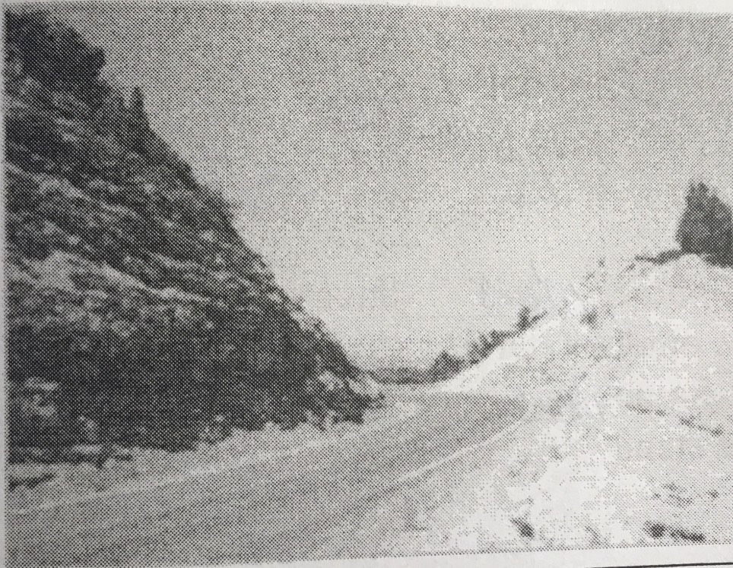

1. The road leads to the ocean
2. The hill is blocking traffic
3. the road curves to the left
4. the trail is steep and Rocky

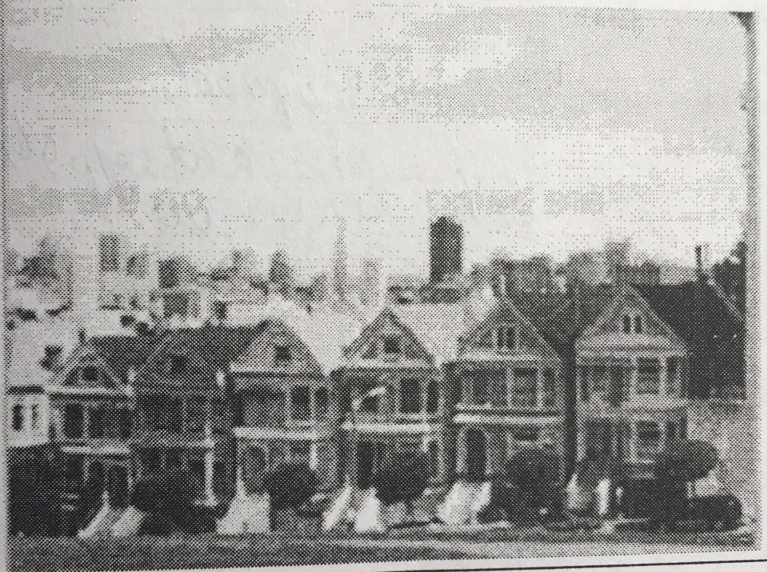

1. there are same houses nect to each other
2. the houses are for sale
3. some plants are being planted
4. the staircases are under construction

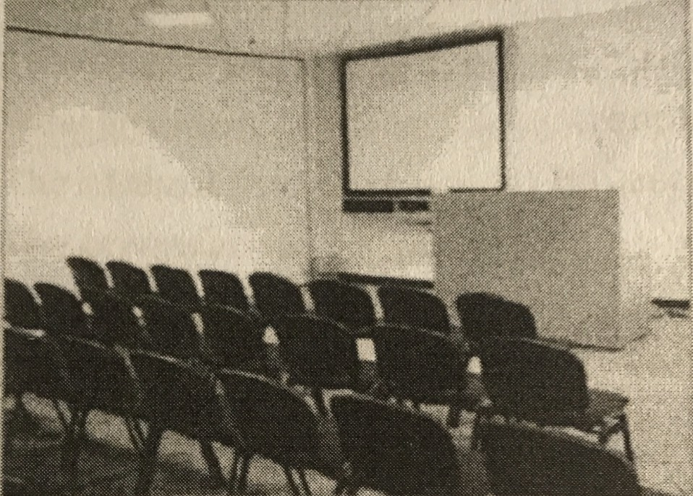

1. someone is speaking into a microphone
2. the chairs have been placed in rows
3. the seminar going to be held soon
4. the screen is being put down

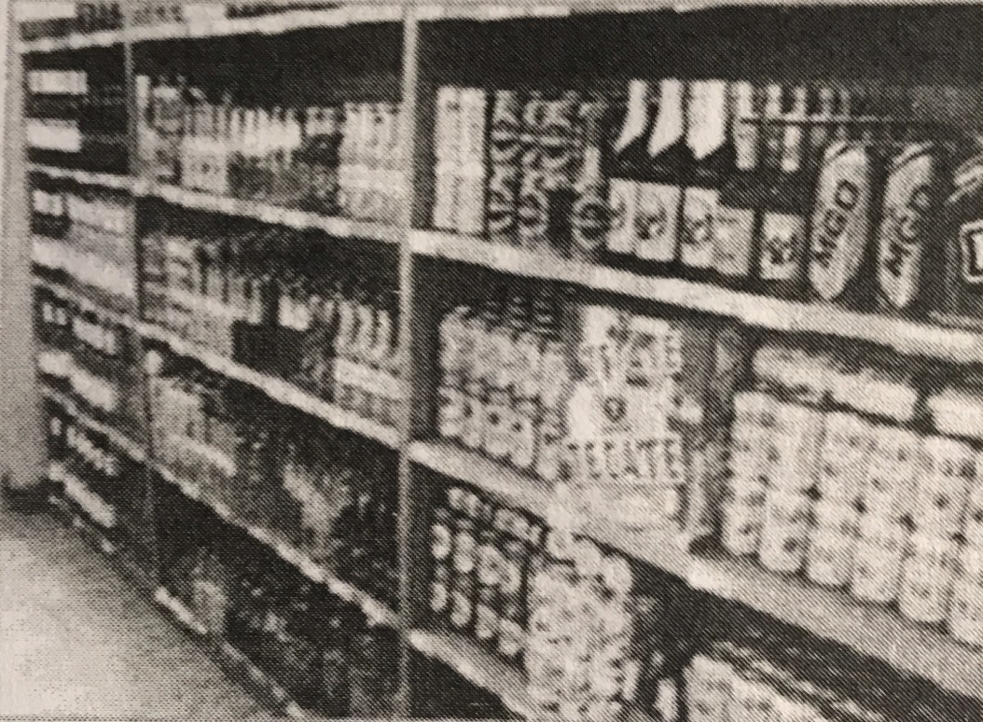

1. the shelves are full of goods
2. the goods are stacked up to ceiling
3. the shelves are being stucked
4. the goods have been mark down

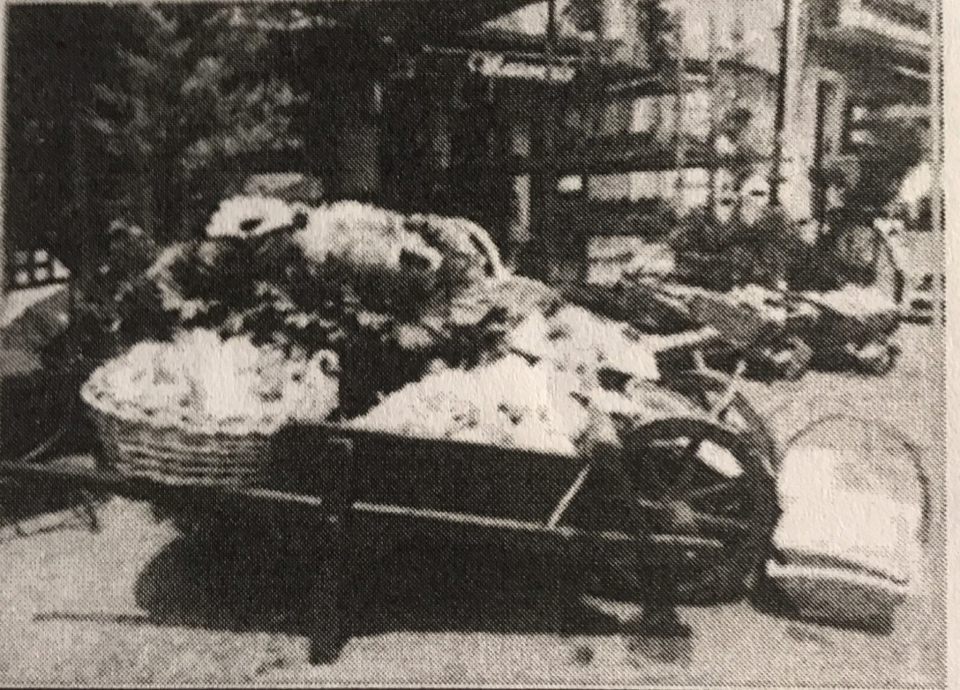

1. people are wheeling some cart
2. items of rolling down the stand
3. some items are being displayed outdoor stand
4. some items are being loaded on the stand

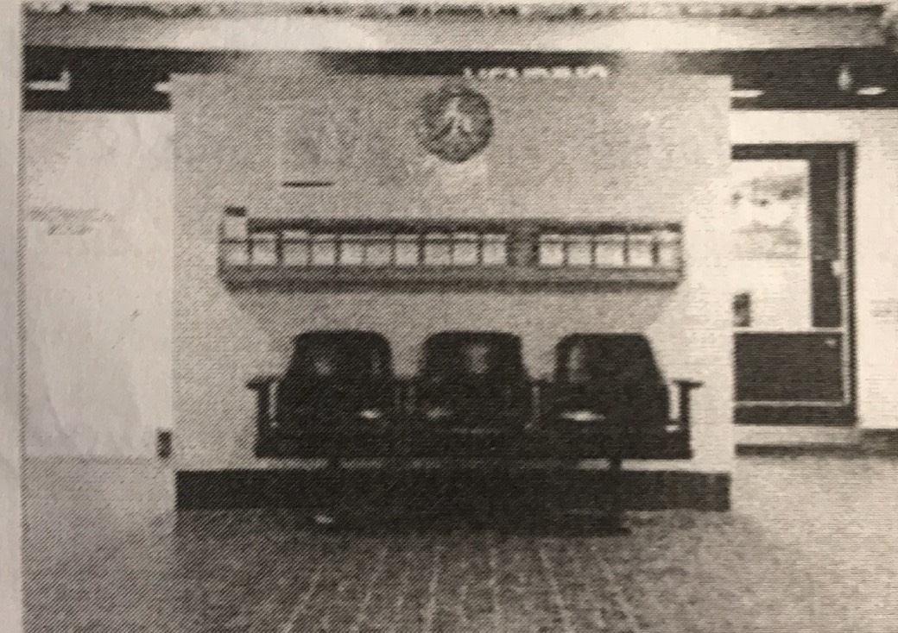

1. the seat are not unoccupied
2. the clock is out of order
3. there is a clock on the wall
4. the seat has been reserved for free

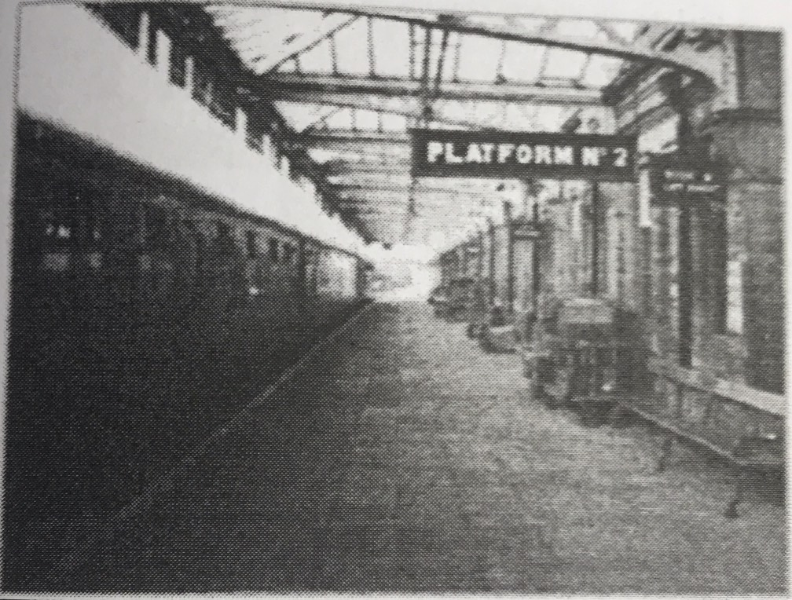

* 1. the train is pointed in to the station
  2. there is noone waitting for the train
  3. the platform is being repainted
  4. the train is going out of the station

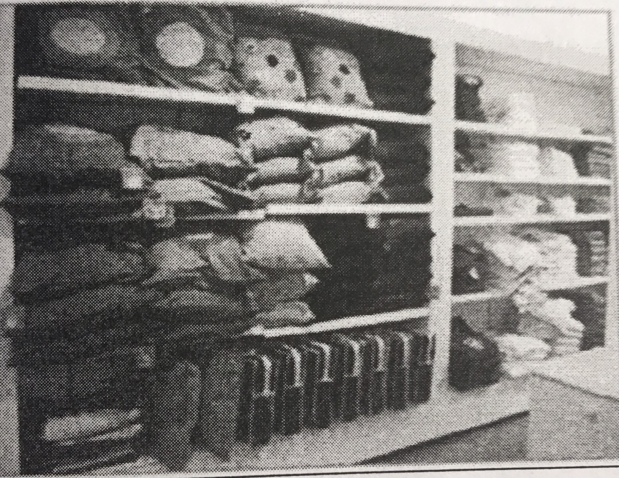

1. some cushions are lying on the floor
2. the items are being removed from the shelve
3. some items have fallen on a ground
4. various items are display on a shelve

various items are displayed on the shelves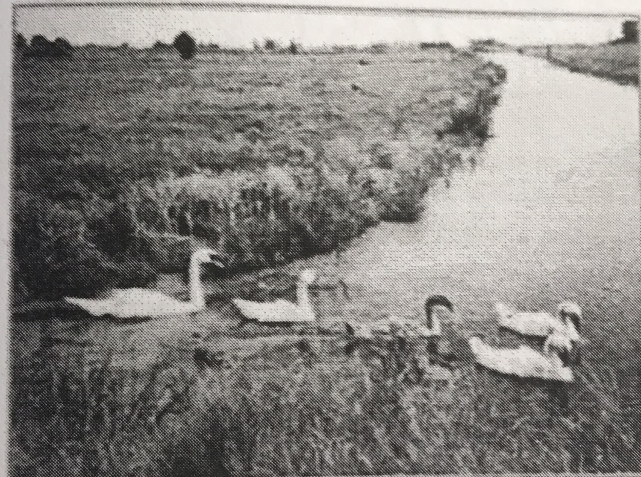

1. the river is flowing in to the sea
2. the ducks are about to fly up
3. there are some duck on a river
4. the birds are going throuht the weeds

Task 5 Listen and fill in the blanks (File 08)

1. The trees are ………………………….the house.
2. ……………………………… a fence……………………… the building.

3. Different kinds of vehicles are ……………………. the road.

4. Garden furniture is…………………………………………….

5. The hillside…………………………………………. the beach.

6. Most of the chairs………………………………….

7. The house is……………………… in the water.

8. The wall is ………………………………………..shelves.

9. ………………………………………a wooded area.

10. Some bowls……………………………………….. on the tabletop.

11. ………………………………………………the fountain.

12……………………………………………………… overhead.

13. A sculpture…………………………………... in the middle of the room.

14……………………………….. a picnic table………………………….. the water.

15. The cups ……………………………………………

16. Many different items……………………………………… the desk.

17. Food is……………………………………………. for sale.

18……………………………………………………………. in the breeze.

19. ………………………………………..a round light…………………………. the ceiling

20. Tiles……………………………………. at the base of column.

Task6: File 09

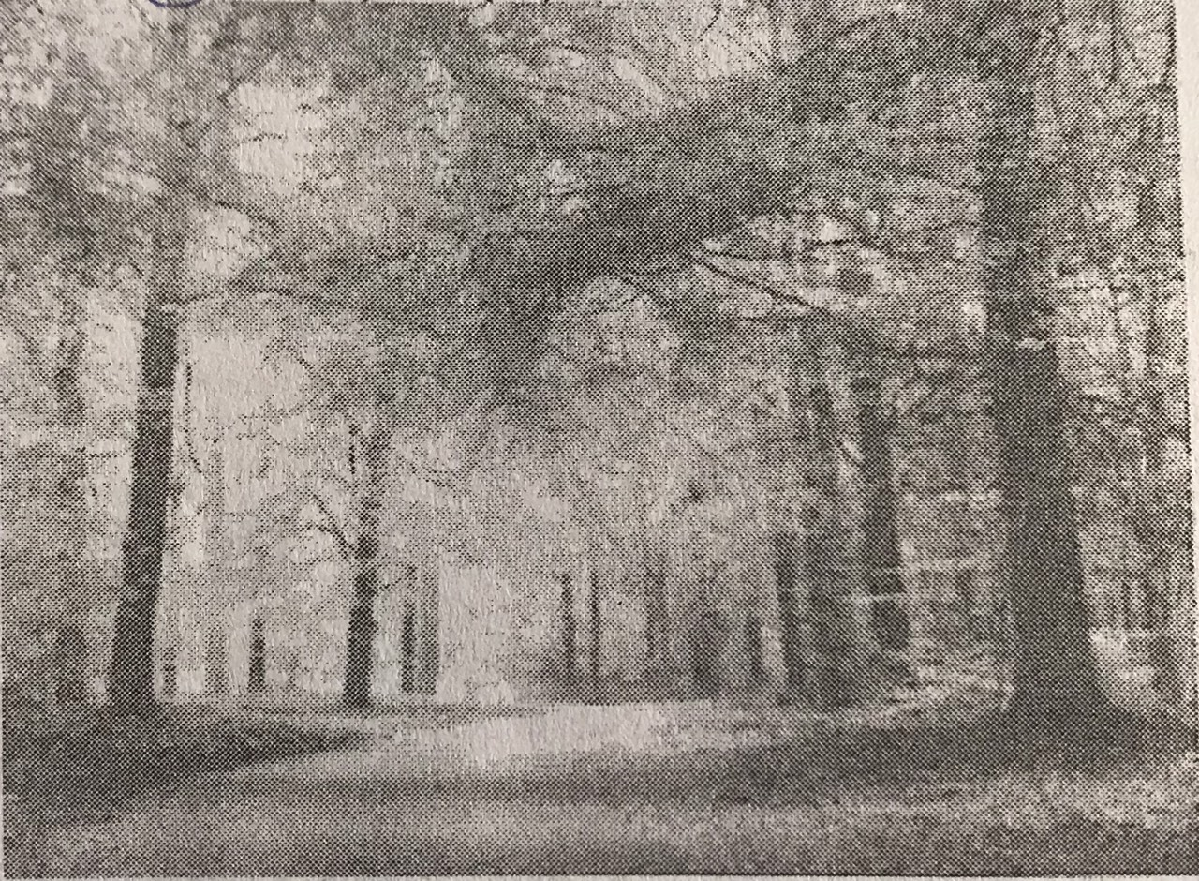

1. There is a path through the woods
2. Trees are being planted
3. The road is being paved
4. Trees have been cut down

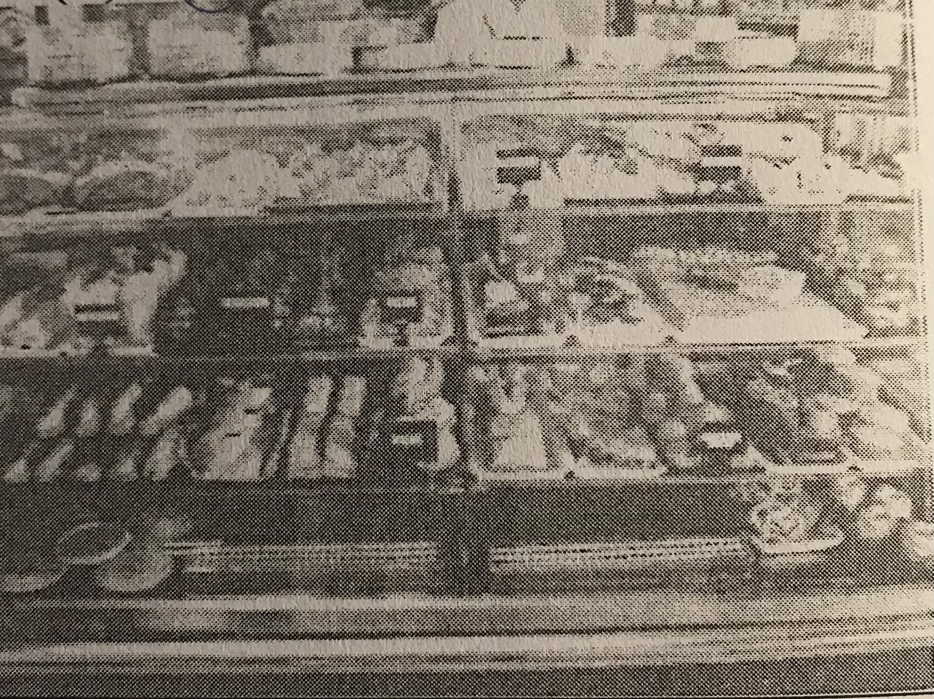

1. Cakes are being baked
2. Desserts are on display
3. Label has been attacked to the cake
4. Cakes are being cut

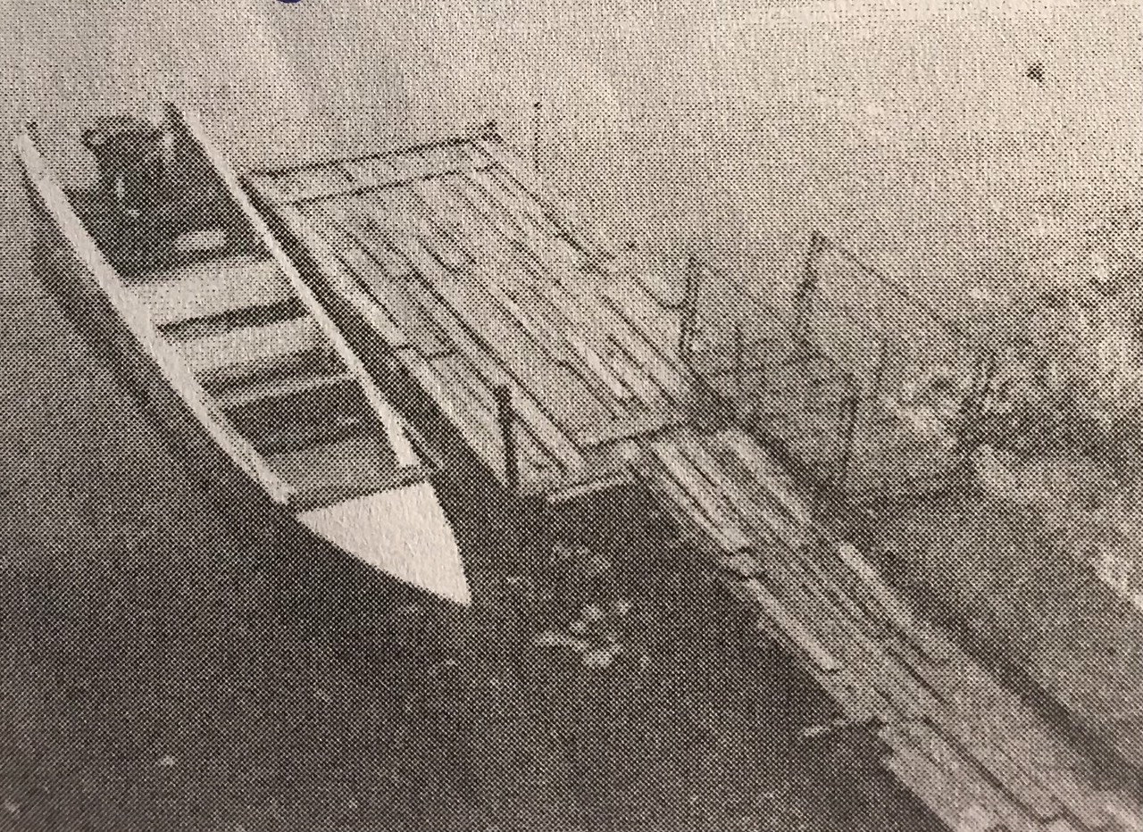

1. A boat is sailing on a water
2. There is a boat by the dock
3. A boat is being belt
4. A boat has been painted

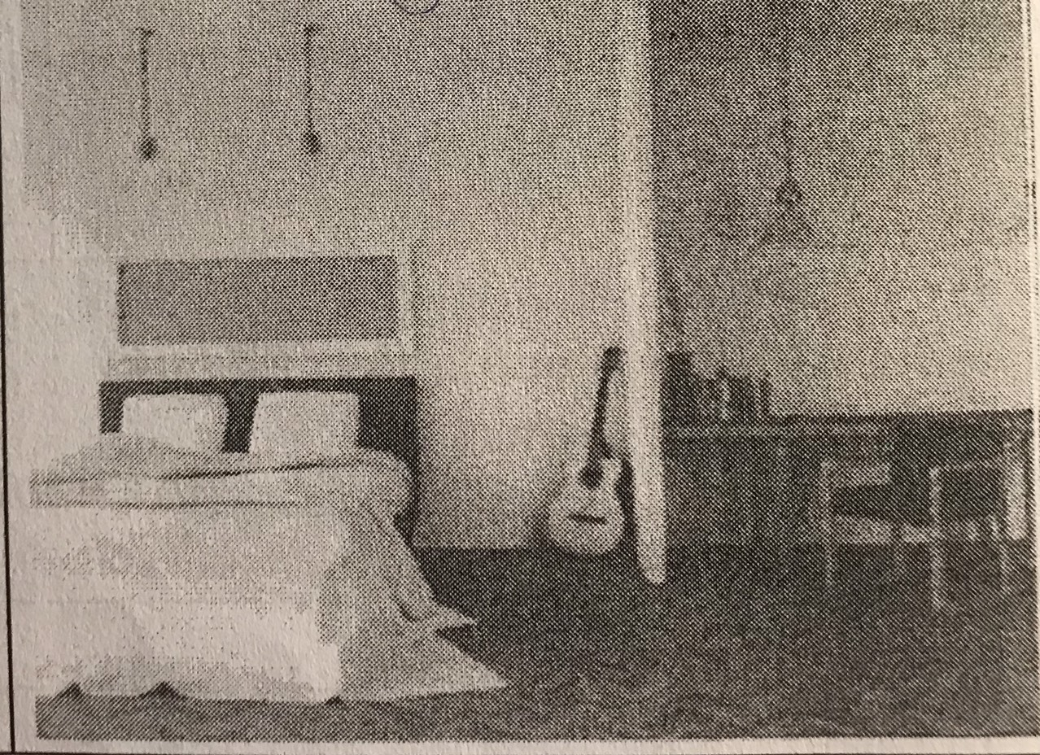

1. The room has been cleaned
2. The bed is being arranged
3. A guitar is leaning against the wall
4. A desk is bettwen the chest

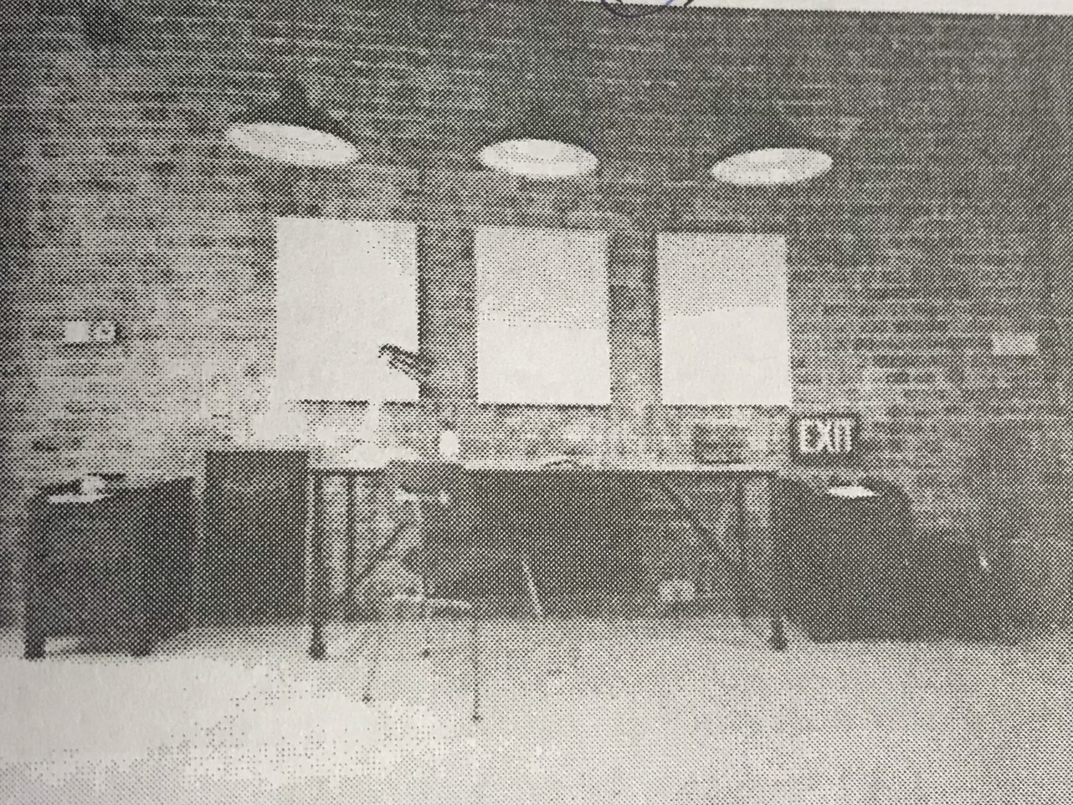

1. The chairs are being arranged
2. The draws are on display
3. The room has been remodal
4. Lights are hanging on the ceiling

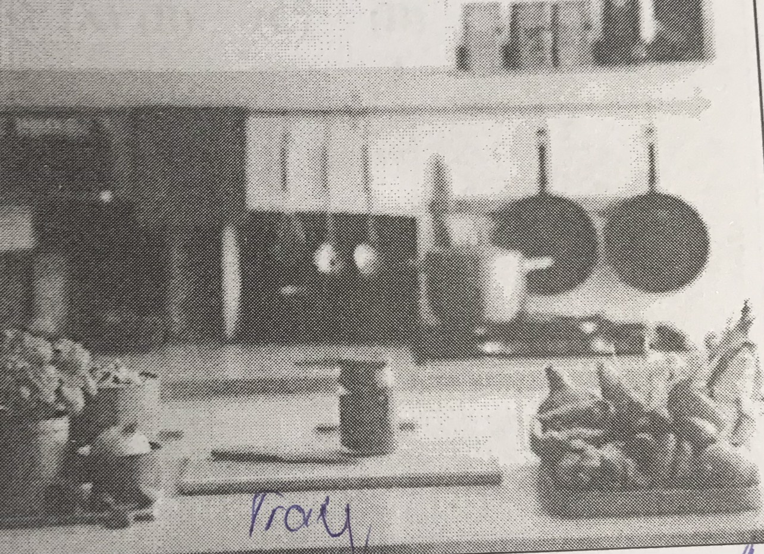

1. Some foods have been placed on a tray
2. The kitchen sink has been install
3. Kitchen tools have been set on floor
4. A plant has been watered